Gains i.e. growth

For the past few months, Labour’s rallying slogan has been very clear: this country needs economic growth. To be fair, growth is pretty great. GDP going up is a sign of increased employment, potentially increased productivity, and it makes government debt more manageable due to increased tax revenues. The room to grow certainly seems to be there: as Rachel Reeves seldom fails to remind the nation, [“had the UK economy grown at the average rate of OECD economies over the fourteen years from 2010, it would be £143.3bn larger”](https://www.gov.uk/government/news/chancellor-unveils-a-new-era-for-economic-growth). There are similar signs for productivity: had pre-2008 trends continued, [it would’ve been around 26% higher in 2022](https://lordslibrary.parliament.uk/economic-growth-inflation-and-productivity/#:~:text=2.1%20Growth%20and%20productivity,-In%20historical%20terms&text=Productivity%20would%20have%20been%20around,the%20pre%2D2008%20trend%20continued.).

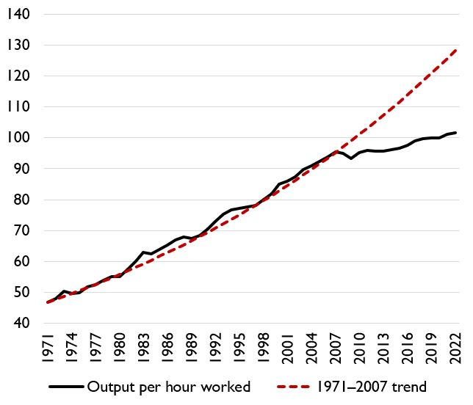

*UK productivity from 1971-2022. Source:* [*House of Lords Library*](https://lordslibrary.parliament.uk/economic-growth-inflation-and-productivity/)

Of course, it’s one thing to acknowledge this gaping Grand Canyon of an output gap. Labour’s plans to fix it leave some wanting. [The OBR estimates that, while the Autumn budget will boost GDP over the next 4 years mainly due to increased demand](https://obr.uk/economic-and-fiscal-outlooks/#chapter-2), it will damage the supply-side by increasing employers’ NICs and crowding out the private sector; crowding out happens when interest rates rise due to government borrowing and subsequently disincentivise private investment. In totality, they project a lower GDP in 2028-30 than if there were no changes at all, but do expect a net positive impact in the early 2030s.

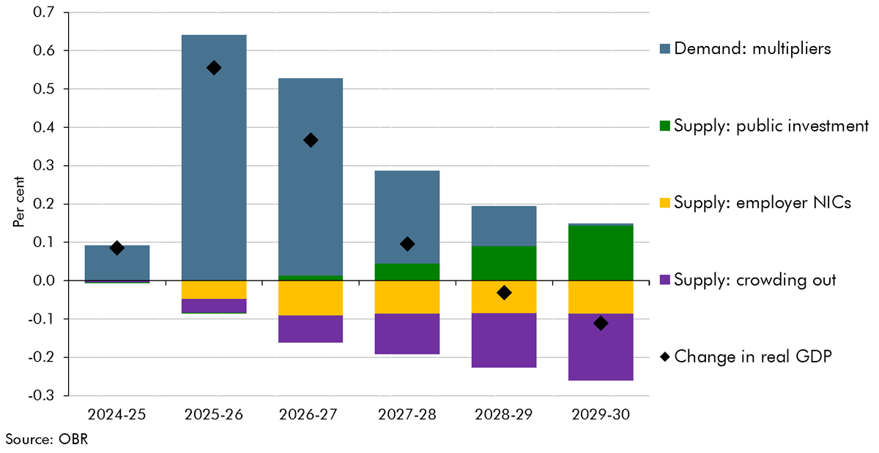

*Policy impacts on real GDP, by measure. Source:* [*Office for Budget Responsibility*](https://obr.uk/economic-and-fiscal-outlooks/#chapter-2)

The OBR maybe missed a trick on this one. It seems to me that the Biden-Harris administration’s large public spending programs [crowded *in* the private sector and beat expectations](https://www.whitehouse.gov/briefing-room/blog/2024/11/26/the-biden-harris-administration-has-catalyzed-1-trillion-in-new-u-s-private-sector-clean-energy-semiconductor-and-other-advanced-manufacturing-investment/); considering it’s exactly that kind of government spending [that Reeves wants to emulate](https://www.bbc.co.uk/news/uk-politics-65695598), it could be Labour’s turn to surprise OBR economists and prove we’ve been underestimating crowding in for far too long.

Setting that whole debate aside for a second, the common theme on both sides is clearly that the country needs *private investment*. The effective and efficient allocation of capital to productive enterprise is, if you think about it, kind of the whole point of capitalism – it is coincidentally also one of the best ways to grow your economy. Unfortunately, it seems our tax policy is contrived in such a way as to spit in the face of “efficiency” and maybe, probably, give a giant middle finger to the concept of “effective”. [At least, that’s what the IFS has determined after analysing how the UK currently taxes capital gains](https://ifs.org.uk/publications/capital-gains-tax-reform).

A capital gain occurs when I sell some asset at a higher value than I paid for it, i.e., a positive net profit. Some examples of taxable assets include property and company shares – however owner-occupied homes and ISAs are excluded.

The problem, pointed out by the IFS, is the *distortionary nature* of CGT. A distortion happens when a firm forgoes an investment that they *would have made*, were it not for the presence of the tax. Obviously, we can all think of times where we want taxes to be distortionary, like carbon, sugar, and cigarette taxes. Private investment is definitely not in that group and discouraging it when we don’t really want to is, for lack of a better word, bad. These accidental distortions happen when the projected return on investment (ROI) is reduced by the tax to such an extent as to make the investment no better than simply putting your money in a savings account. Every time this happens, we forgo potential new economic capacity and employment simply because of our tax structure. Even worse is this:

For a relatively low CGT, like 10%, we lose the least valuable investments – if we assume the savings rate is 5%, then only investments with expected returns between 5%-5.56% are effectively lost. However, imagine CGT rises to 40%. With the same savings rate of 5%, expected returns all the way up to 8.33% are not worth it. The economy not only misses out on a greater quantity of private investment, but this lost investment also becomes more valuable – an enterprise with an 8.33% expected ROI likely has more room to grow than one with an expected ROI of 5.56% and investing in the former rather than the latter is far better for the economy. To really summarise this key message I took away from the IFS report: the government’s 4% increase of the top rate of CGT to 24% likely reduced the efficient allocation of capital by *more* than 4%.

Fortunately, taxing gains is still on the table. I say fortunately, because – to me at least – it’s clear why [CGT consistently ranks highly on the list of taxes people want to raise](https://taxpolicy.org.uk/2024/10/26/the-publics-surprising-choice-of-tax-increase-and-why-we-should-ignore-it/). It doesn’t feel right that people who make money with money should have to pay less tax than the rest of us, just so we can bathe in an abstract concept of “economic efficiency” that, let’s face it, no one really cares about. And while we’ll just have to trust economists that allocative efficiency is pretty great, we can still have our cake and eat it too, ensuring that productive investments help the public purse as well as the private sector.

The trick is, rather than levy CGT on the whole gain, only tax the *extra* gain on top of what was essentially risk-free, i.e., the savings rate in an economy. With a savings rate of 5%, investments with a 5% ROI don’t get taxed *at all*. With an expected 8% ROI, that bonus 3% will be taxed at whatever rate we put CGT at – and that’s the great part: with this system, CGT can be set as high (or as low) as we want, without discouraging investment relative to cash savings.